Project A

Jawal Trivedi & Nabeel Azafer

Contents

Executive Summary 3

Design Process 3

Mechanism Specifications 4

Shaft Rotational Speed 4

Gear Ratio 4

Bill of Materials 4

Summary of Design Calculations 6

Required Speed Output 6

Compound Gear Train 7

Cam calculations 7

Summary of Analysis 7

Dynamic Simulation 1 7

Dynamic Simulation 2 7

Summary of Prototype Manufacturing 7

Justification of 3D Printing 7

Design Decisions based on 3D Printing 8

3D Printing Build Settings 8

Print 1 8

Print 2 8

Print 3 8

Decisions for Ease of Assembly 8

Iterative Improvements 9

Time Cost Analysis 9

Conclusions 9

Appendix 9

Appendix A – Figures 9

Appendix B – Calculations 9

Appendix C – Statement of Contributions 10

# Executive Summary

Project A revolved around designing a mechanism with two mechanical elements which fits into a box of cubic volume 100mm³. The aim of the mechanisms is to transfer a steel ball of 9.5mm diameter from one end of the box to the other. The mechanical elements must convert an input rotation into the desired motion to drive the ball in exactly 5.0 seconds. Our team has iterated a solution which includes, a support structure, a cam and follower mechanism and a compound gear train.

# Design Process

During Project A, our team mainly focused on the conceptual design and prototyping phases of the design process. The design process was initialised with a close look at the project specifications and creating a PDS, thereafter we developed a product decomposition (refer to figure X) to break down the overall design problem. Using the this, the next stage was to identify the two or more mechanical elements. We individually came up with two ideas each for the different combinations of elements and used those to develop a Pugh’s Matrix (refer to Table 1). From this we decided on a cam & follower alongside a compound gear train. With a brief iteration back to the product decomposition, we discussed the type of support and collectively agreed that a ramp connecting the entry and exit holes would be best. Once the two elements and the support type were agreed on, we fixated on deciding the joining mechanisms. Initially we had thought of using the M3 series of nuts and bolts to fix our ramp, however later in the prototyping phase we made a judgement call and decided to use superglue. Similarly, in terms of joining the gears and shaft together we had planned to extrude the shaft out of the gear with a key, however, this was substituted by a steel rod and superglue during the prototyping phase.

# Mechanism Specifications

## Shaft Rotational Speed

The required shaft rotational speed is 60RPM.

## Gear Ratio

The overall gear ratio of the compound gear train is 8:1. The ratio of each set of meshing gears is 1:2 and 1:4.

## Bill of Materials

The Bill of Materials below excludes the parts provided by the University, e.g. the box sides and the driveshaft coupling.

|  |  |  |
| --- | --- | --- |
| **Part Name** | **Image** | **Qty** |
| Entry Ramp |  | 1 |
| Exit Ramp |  |  |
| Coupling |  | 1 |
| Gear 1A |  | 1 |
| Gear 1B |  | 1 |
| Gear 2A |  | 1 |
| Gear 2B |  | 1 |
| Steel Rod 1 (42.5mm) |  | 1 |
| Steel Rod 2 (74.5mm) |  | 1 |
| Cam |  | 1 |
| Follower |  | 1 |
| Support 1A |  | 1 |
| Support 1B |  | 1 |
| Support 2A |  | 1 |
| Support 2B |  | 1 |

# Summary of Design Calculations

## Required Speed Output

According to a dynamic simulation model (refer to Dynamic Simulation 1), it takes about, 0.3 seconds for the ball to come down the ramp. Therefore, the ball needs to be obstructed by the follower for about 4 seconds. If the dwell of the cam lasts for 180° and the input speed is 60RPM, Calculation 1 shows the gear ratio comes to 8:1.

## Compound Gear Train

Calculation 2 shows the gear ration of each meshing gears in the compound gear train. If the overall ratio needs to be 8:1, then first set of meshing gears needs to have a ratio of 1:2, and the second set of meshing gears needs to have a ratio of 1:4.

# Summary of Analysis

## Dynamic Simulation 1

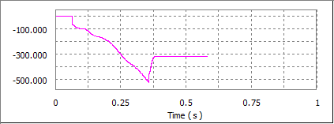The first analysis was a dynamic simulation of the steel ball rolling down the ramp. This was carried out to extract the time taken for the ball to roll down the ramp. The simulation estimated around 0.3 seconds (refer to figure X). Figure X below shows the graph of the velocity of the ball (in mm/s) in the x-direction. As the ball moves in the negative x-direction the velocities shown are negative. From the graph, our team decided to put the obstruction by follower when the velocity is relatively small so there won’t be too much deflection.

## Dynamic Simulation 2

The second dynamic simulation was done to check whether our mechanism outputs the steel ball in the time predicted. The analysis showed that if the follower height was increased by 2mm, and the profile of the cam profile was reverted to the pear shape, the time taken is approximately 5.06 seconds which falls under the tolerance. Figure X below shows the coordinates of the ball in X (Blue), Y (Pink) and Z (Red) direction in mm, over time.

# Summary of Prototype Manufacturing

## Justification of 3D Printing

Throughout this project we only used a 3D printer to print the parts. We decided against using a laser cutter because the only parts we could’ve laser cut were the gears, due to the thickness limitations. Besides this, when we were up to the prototyping phase, we didn’t have enough time to use both, hence we only used the 3D printers.

While using the 3D printers, we simultaneously printed our first two prints, and produced parts that were either incorrectly dimensioned (calculation error) or of poor quality (printer error). On our third attempt we were able to print the correct parts, however, during post-processing, we damaged the coupling to the drive shaft. Due to this and a few design changes after our analysis, we executed a fourth and final print.

## Design Decisions based on 3D Printing

A slot in the Entry Ramp was created for the follower to slide up and down in. This design decision was made knowing that we are 3D printing the part, otherwise it would have been too difficult to fabricate. We also decided not to have a roller on our follower as the curved edge from 3D printing would be adequate.

## 3D Printer Build Settings

### Print 1

As we were inexperienced in 3D printing, we heavily relied on the guidelines provided. We used an Original Prusa Mini printer with a 0.4mm nozzle. We used 0.25mm layer height with variable layer height on adaptive at 0.5. We also added support material everywhere as we were uncomfortable deciding this manually. The build plate was arranged automatically according to the PrusaSlicer software (refer to Figure X). As mentioned previously, the printer was slightly faulty and thus, Jonathan changed a few settings such as the nozzle temperature using the Expert mode in the software.

### Print 2

The second print was also on an Original Prusa Mini (0.4mm nozzle. On this print however, we used a general layer height of 0.20mm for a better quality with adaptive in variable layer height with preference to quality (0.3). Again, we added supports everywhere as this print had an overhang used the arrange function to automatically arrange the parts onto the bed (refer to figure X).

### Print 3

We were able to use an Original Prusa i3 MK2S (0.4mm nozzle) on our third attempt. The general layer height selected was 0.35mm, with variable layer height selected on adaptive at 0.5. Supports were added everywhere, and the arrange function was again used to automatically set the parts on the bed (refer to figure X).

### Print 4

We used the _____ in the final print. A general layer of 0.35mm was selected with variable layer height on at 0.5. Supports were added everywhere and the plate was arranged automatically (refer to figure X).

## Decisions for Ease of Assembly

Our original print had a keys/keyway and a shaft printed; however, both were excluded from the final assembly. The keys/keyway were pointless due to the dimensional accuracy of the 3D Printers. We excluded the shaft extrusion because as we were snipping off the support material on the gears, we accidentally ripped of part of the shaft which would’ve been catastrophic if that happened during testing. In replacement of these two features we settled on using the 3mm steel shaft superglued to the gears and cam.

## Iterative Improvements

As shown in Figure X below the Ramp went through an iterative design process which improved its functionality over the process. The second iteration shows an input similar to a hook, this was added to account for a high input velocity of the ball, which made the design more robust. The combination of the first two designs is shown in the third iteration. The fourth and fifth iteration shows, a slot for the follower was implemented and the exit ramp improved such that it connects to the exit hole rather than hanging freely. The fifth image shows the entry and exit ramps in conjunction, which was used in the final assembly.

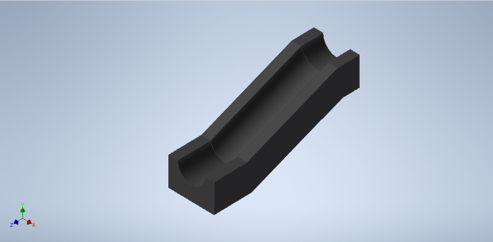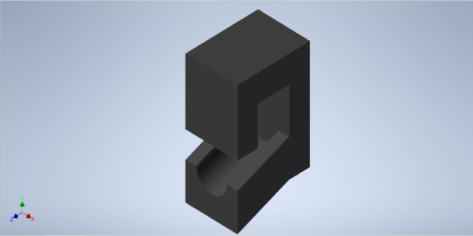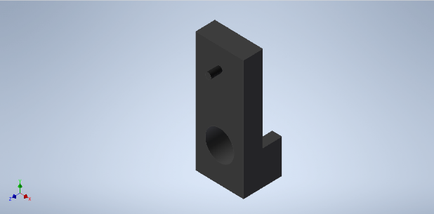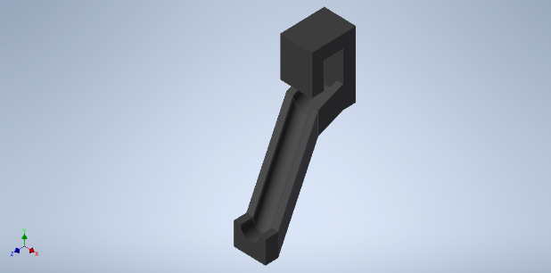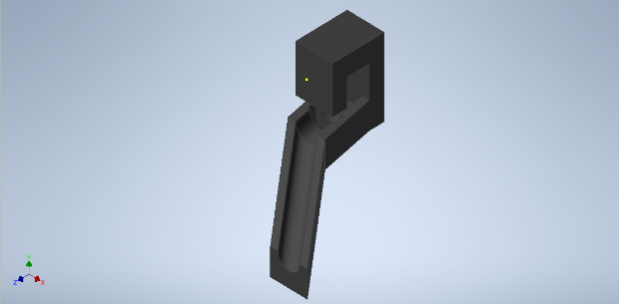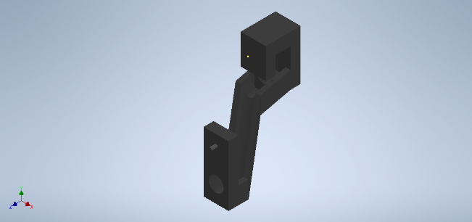

In figure X the iterations of the cam are shown. The profile of the cam was changed in all successions. The second iteration the profile was changed from a snail shape to a pear shape as there was a significant drop, which would apply unnecessary force onto the shaft. The third iteration was created as there was limited space and the previous profile was obstructing the ramp. A keyway was also added in this occurrence to drive the shaft more smoothly. The fourth succession was created because an unnecessary dwell and rise was noticed in the behaviour of the follower. The fifth iteration was created after the analysis showed that this pear-shaped profile achieves the closest time to 5.0 seconds. The keyway was removed through the iterations as it proved to be useless in assembly.

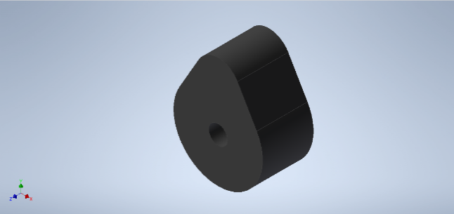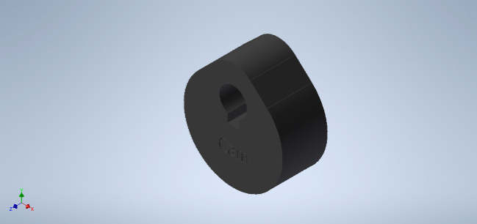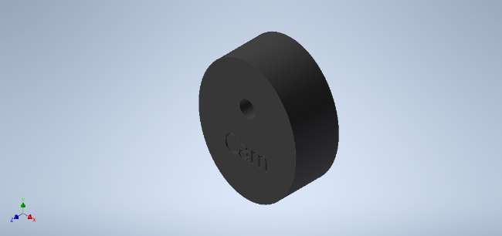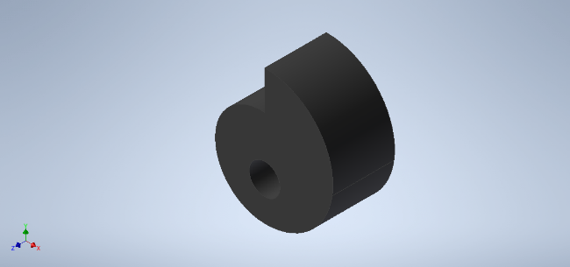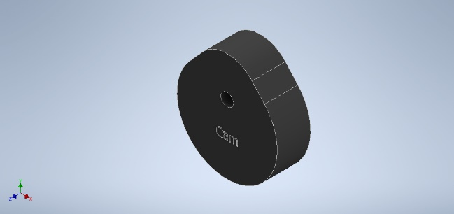

## Time Cost Analysis

|  |  |
| --- | --- |
| **Category** | **3D Printing** |
| Material | 105.39g at $50/kg  $5.30 |
| Energy | 7.6 hours & 50W at $0.2/kWh  $0.077 |
| Labour | ~2 hours @ $30/hr  $60 |
| Total Time | 9.6 hours (9hr 40min) |
| Total Cost | $65.40 |

# Conclusions

Throughout Project A, we learned a lot about Prototype Manufacturing, more specifically 3D Printing. The solution we derived included a ramp for the ball to roll down, a follower driven by a cam to obstruct and delay the ball, and a gear train to time and drive the cam. Alongside the main elements, we created support structures and couplings for the gear and input shaft respectively. To join the gears, we utilised the 3mm steel rod and superglue. The overall mechanism converts rotational motion by the input to linear motion produced by the follower. Using analysis tools such as dynamic simulation we were able to predict that our mechanism meets the required time of 5 seconds.

# Appendix

## Appendix A – Figures

## Appendix B – Calculations

|  |  |  |
| --- | --- | --- |
|  | $$\frac{180 deg}{4 sec}=\frac{45 deg}{sec} \\ ∴ \frac{45 deg}{sec}×\frac{1 rev}{360 deg}×\frac{60 sec}{1 min} \\ =7.5 RPM \\ So the overall gear ratio will be 60:7.5 or 8:1$$ | 1 |
|  | $$\frac{ω_{input}}{ω_{output}}=\frac{ω_{4}}{ω_{3}}×\frac{ω_{2}}{ω_{1}} \\ \frac{1}{4}×\frac{1}{2}=\frac{1}{8}$$ | 2 |

## Appendix C – Statement of Contributions

|  |  |  |
| --- | --- | --- |
| **Category** | **Jawal** | **Nabeel** |
| PDS | 50% | 50% |
| Product Decomposition | 50% | 50% |
| Pugh’s Matrix | 50% | 50% |
| Calculations | 60% | 40% |
| CAD Model | 40% | 60% |
| Dynamic Simulation | 20% | 80% |
| 3D Printing & Assembly | 80% | 20% |

## Appendix D – Tables

|  |  |  |  |  |
| --- | --- | --- | --- | --- |
| Categories | Straight-line linkage with cam | Scooping sliding mechanism | Gear trains with cam | Gear Train with sliding crank |
| Accuracy | Can accurately move the marble vertically  N/A | May not be able to accurately pick up the ball  -VE | Could be precise once we have the correct timing on the cams  EQUAL | Would be accurate as we just need to do the sliding crank calculations.  EQUAL |
| Robustness | Since the cam element will block the ball variations in ball input velocity won’t have a major impact  N/A | Differing ball input velocities may result in different outcomes  -VE | Could be an issue with a high-velocity input of the ball  -1 | Quite robust because, as the marble is inputted its motion instantly changes.  +VE |
| Ease of Assembly | 4 bar linkage mechanism may be difficult to assemble, due to multiple joints  N/A | Relatively simple assembly  +VE | Cam mechanism could be complicated to assemble.  +VE | The sliding crank would be difficult to assemble  -VE |
| Ease of Manufacturing | Will likely have to 3d print joints individually which can take time  N/A | Not many components to print, but the sliding mechanism will take time to print  EQUAL | Many different components to print, so could take a while  EQUAL | Not too complicated to print with a 3D printer.  EQUAL |
| Design Simplicity | The cam element is simple, the linkage is slightly more complex  N/A | The sliding element will likely be very complex to design and implement  -VE | Quite a simple design as it only has two easy to understand mechanisms  +VE | A complicated design due to the positioning of the two mechanical elements  +VE |
| Number of Moving parts | Quite a few moving parts like joints, gears etc  N/A | Only a few moving parts  +VE | Various moving parts includes gear train and cams. Will also needs multiple bearings.  +VE | Not that many moving parts, only gears, crank, conrod and slider.  +VE |
| Overall | N/A | -1 | 3 | 2 |

Table 1: Pugh's Matrix